Jetplex Circle Business Park Location Map

“All roads lead to Jetplex Circle Business Park”

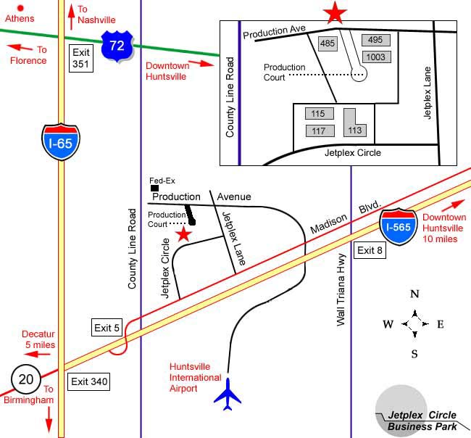

“Jetplex Circle Business Park is ideally locted to serve Northern Alabama.”

From the West: From I-65, take Exit 340 East on I-565. Take exit 5 to Madison Blvd(AL 20). Turn left on Jetplex Circle or Jetplex Lane to the park.

From the East: Take I-565 to Exit 8 at Wall Triana. Go north on Wall-Triana to Madison Blvd(AL 20). Proceed West on Madison Blvd. Turn right onto Jetplex Lane or Jetplex Circle to the park.

http://www.jcbp.com

